Research on Gentrification
Student’s Name
Institution
Date

Research on Gentrification
Introduction
Gentrification refers to the process the wealthiest individuals move to low urban regions and transform it by improving housing and attract new businesses while displacing the local inhabitants. It has been associated with negative implications like forced displacement, fosters discriminatory behavior by those in power, and brews spaces, excluding the low-income earners as well as the people of color. In America, numerous cities have been gentrified. They include San Francisco, Oakland, San Diego, Washington DC, and many more. In these cities, the original inhabitants have been displaced, rental prices have increased, and discriminatory behavior has been immense. The paper’s thesis explores data on communities that have been gentrified and determine how rent control, race issues, and bohemian cultures have played a role in gentrification in the US.
The research questions addressed by the study include:
- How has race issues contributed to gentrification and displacement of low-income individuals and minorities in the US?
- What is the role that rent control has played in gentrification in the US?
- How has Bohemian culture led to gentrification of dilapidate neighborhoods in the US?
Literature Review
Gentrification was a term coined by Ruth Glass, a British sociologist, during the 1960s. She used it to describe the displacement of the working-class residents residing in London neighborhoods by newcomers of the middle-class. From the time it was discovered, gentrification has been considered as a shift in neighborhood change leading to the displacement of the natives or locals of a particular social class and culture by another prosperous class associated with the appreciation of property values. In regard to America, the segregated residential establishment of cities engenders ample situations necessary for gentrification to take place along racial lines (Tehrani, Wu, & Roberts, 2019). Many cases of gentrification and racial displacement in America are visible when the wealthy white newcomers usually displace the native minority residents.
Gentrification denotes a multifaceted form of neighborhood change (Winsett, 2019). It is usually noticeable in the upgrading of the built structure within neighborhoods. This is because houses become refurbished, and many business ventures are created. Broader political and economic forces play significant roles in spurring gentrification in the US. The government’s policy decisions may affect both transportations as well as the availability of resources within neighborhoods. The interchange between the government and the public regarding zoning and the distribution of public resources has a profound influence on neighborhood desirability. The late Neil Smith noticed the gentrification of Baltimore’s Inner Harbor while working on his Ph.D. at John Hopkins University. He established the drivers that result in gentrification etched on land rents (Smith, 2020). Land rent encapsulates the depreciation as well as physical deterioration of older built establishments along with an increase in the potential income returns from the lands they have been built on.
Besides, the influx of wealthy whites to low-income minority neighborhoods has been considered a form of racial exclusion from urban regions with vibrant economies. Even though racial segregation has reduced in the US compared to the way it used to be before, discrimination is still a menace the country grapples with. This has taken the form whereby incumbent black homeowners have driven away from their residential areas as inspired by racial disparities in home-lending access. From 1993 to 2000, black and Hispanic applicants for mortgages in gentrified neighborhoods were 2.32 times and 1.96 times more likely to be deprived of credits than non-Hispanic white applicants (Freeman, & Braconi, 2004). Washington, DC, is a major city that has experienced gentrification for quite some time. The most vulnerable individuals are low-income residents and moderate-income Washingtonians of color. Wanton job and housing discrimination have crippled the opportunity for blacks and other minorities to amass wealth. The table below shows the magnitude to which neighborhoods in Washington, DC, have been gentrified.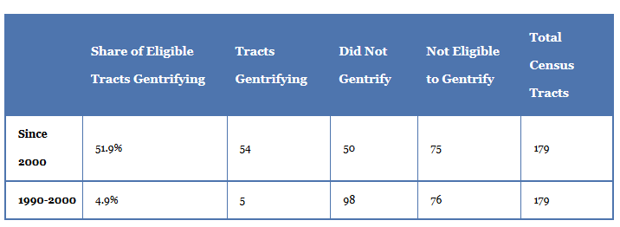
Cocola-Gant (2019) unravels the history of redlining prominent during the vast parts of the 20th century. Low-income and minority neighborhoods were prevented from gaining access to credit by a combination of local policies linked to zoning, restrictive covenants as well as informal segregationist practices such as residential steering. The disinvestment pattern motivated gentrification and displacement of the low-income individuals and minority groups. Philadelphia is one of the cities where gentrification took part immensely. The deeply racialized decisions such as fostered residential segregation, wealth, and opportunity became stripped from low- and moderate income neighborhoods (Cocola-Gant, 2019). The people of color were segregated at out-migrated to other regions as the affluent white incomers pushed them away due to a divisive and racialized decision. Below is a map showing changes in low-cost rental units in gentrifying Philadelphia census tracts produced by the Philadelphia Reserve Bank.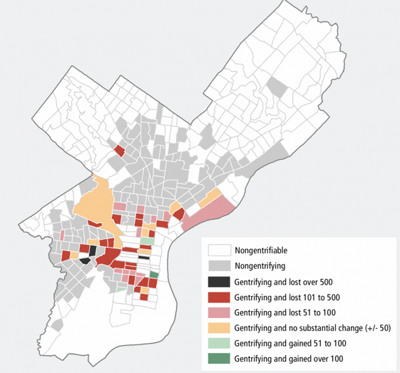
Arts and artists have been widely credited for sparking neighborhood change that has resulted in both positive and negative impacts. Individual artists, artistic businesses along with artistic spaces such as music venues, art studios, and theatres have been critiqued as playing fundamental roles in sparking gentrification in the US. Artists have been considered to help set the stage for change by utilizing their social capital (Hamidi, 2020). Hence by utilizing their sweat equity, they appealingly revalue places by changing impoverished and disenfranchised areas into a ‘neo-bohemia.’
Methods
The study wants to quantify variations visible in people's displacement in the US urban areas by examining the changes at the census tract level (neighborhood) utilizing the national US census data normalized by the longitudinal tract database (LTDB). Normalizing the census data is essential since tract boundaries can change over some period, thereby resulting in inaccuracies. LTDB data was analyzed for socio-economic changes from 2000 to 2013 regarding the fifty US states. During the decennial census data for 2000 and 2010, population changes were assessed and normalized by the LTDB. This study used a methodology created by Freeman and applied by the Philadelphia Federal Reserve to identify gentrified areas (Freeman, 2009). The technique encapsulates examining the educational level as well as the economic status of residents along with the value of properties within the neighborhood during the inception of the census period. Some of the checks for the assessment included:
- Imminent gentrification is dictated by including every eligible tracts and identification of tracts categorized in the top 60th percentile for upsurges in both median home value as well as the percentage of college graduates
- Eligibility is demystified by tracts in the Core Based Statistical Area (CBSA) that are below the 40th percentile in both median household income as well as median house value. Also, the population ought to be 500 residents or higher at the start of the period.
- Census tracts found to have met the above listed criteria were regarded as undergoing or have gone through gentrification.
The study reviewed every tract of changes in the populaces of the racial subgroups. The changes were examined based on two criteria:
- Did the percentage of the population of the racial group drop by more than two standard deviations from mean of the entire census tracts?
- Did the residents’ absolute number from the racial group plummet by at least five percent?
In case the census tract gentrified and realized both of the criteria, it became recognized as having undergone cultural displacement. Cultural displacement occurs when the tastes, norms as well as desires of newcomers oust and supplant those of the native residents. The decline in minority subpopulation was utilized as a proxy since cultural transformation of neighborhoods is difficult to measure directly. The examination of population shifts were conducted using decennial census 2000 and 2010 population data.
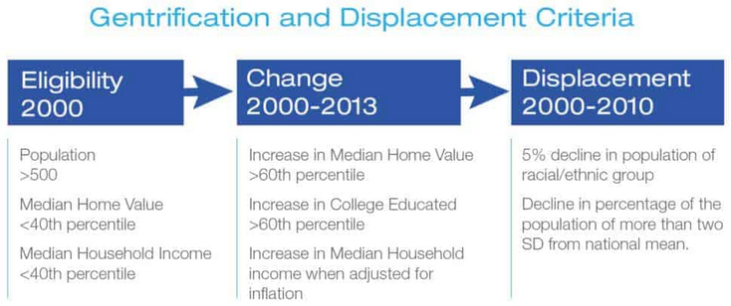
Results
- National changes due to gentrification
From the study, 90.7% or 67153 census tracts had a metropolitan description and are allotted to an urban region. 16.7% or 11196 tracts of the urban tracts met the criteria of being eligible for gentrification in 2000, which marked the inception of the inspection period, as indicated in the figure below. One thousand forty-nine census tracts met the entire checks of gentrification that include surges in median home value, educational attainment as well as rises in income by 2013. It appears that gentrification is assembled in segments of larger and economically sound cities closer to central business districts (Preis et al., 2020). Due to the proximity to employers and assembling of amenities and services related to an urban lifestyle, residents have been drawn to the neighborhoods. Of the gentrified tracts, a total of 232 or 22% were displaced.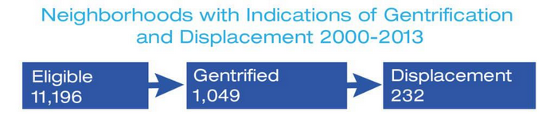
Furthermore, from the census tracts collected, gentrification was found to have concentrated within the largest urban areas. As indicated in the table below, nearly a quarter – 24% - of every urban area or CBSAs had a gentrification of at least one tract between 2000 and 2013. From the table it can also be noted that only one tract gentrified in 13% of towns and cities in the US. CBSAs refers to urban regions with population not less than 10,000 and encompass small metropolitan areas.
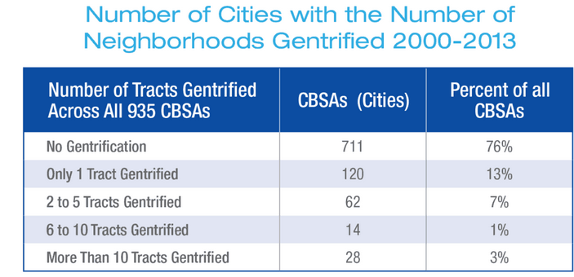
The cities were listed in accordance to the highest rates of gentrification. The cities with the highest rates of gentrification encapsulated New York City, Los Angeles, Washington, D.C, Philadelphia, Baltimore, San Diego, as well as Chicago.
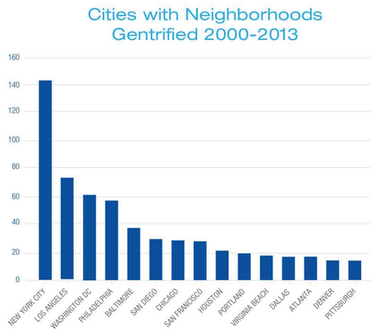
In America, cities with the highest rate of gentrification encompassed New York City, Washington, DC, Baltimore, San Diego, Los Angeles as well as Chicago. The cities made up for about half of the total gentrification nationwide. New York City, Los Angeles, and Chicago are the three largest metro areas in the top seven for the number that experienced gentrification, as shown in the figure above. The top tier cities in population size have significant neighborhoods and are economically vibrant compared to second and third-tier cities (Hwang, & Ding, 2020). Assessing cities by the proportion of communities eligible in 2000 and gentrified over the next ten years presents a meaningful illustration of gentrification rates in certain areas, as shown in the figure below.
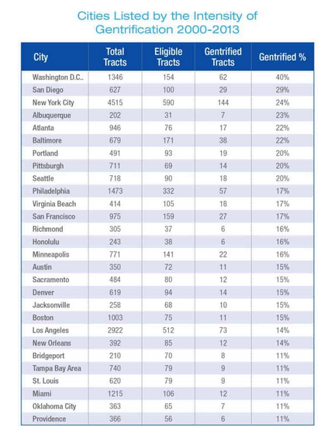
Assessing the maps of various cities unearths patterns of concentrated gentrification in some of them while more diffuse patterns are noticed in others. From analyzing the Baltimore map in the figure below, it shows the concentration of gentrification within the Inner Harbor, which expanses from downtown north towards John Hopkins University. In the largest cities, Chicago, Los Angeles and New York City, the patterns of gentrification are more scattered. However, Baltimore, Philadelphia and Washington have concentrated gentrification within their central business district.
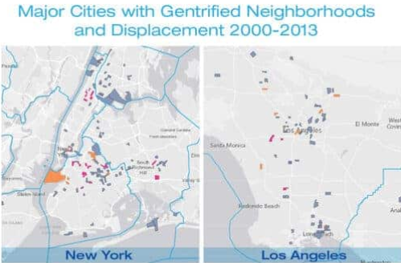
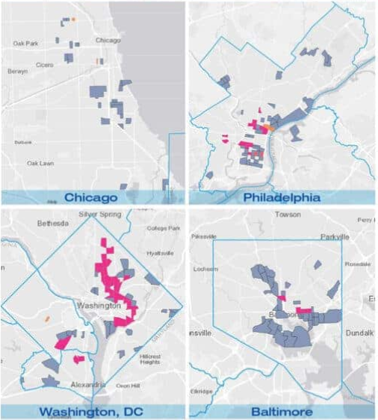

b. National changes due to displacement
Cultural displacement was assessed by inspecting the reduction of black and Hispanic individuals within census tracts. From the data collected from gentrified tracts in the US, 187 tracts portrayed some level of black displacement while 45 tracts indicated displacement of Hispanics as highlighted in the table below. Nationally, over 135,000 residents were impacted. However, white residents significantly increased in many tracts. Asians, Hispanics and blacks experienced heightened gentrification in their residential areas resulting in their displacement by the affluent white incomers.
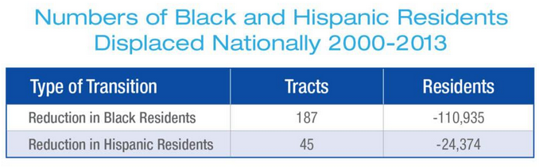
The study calculated the average losses garnered in metropolitan regions that were gentrified and the residential population losses by the black or Hispanics. The average loss per tract was 593 black residents in the case of black residential displacement. Black experience the most average loss per tract in New Orleans as compared to other cities in America.
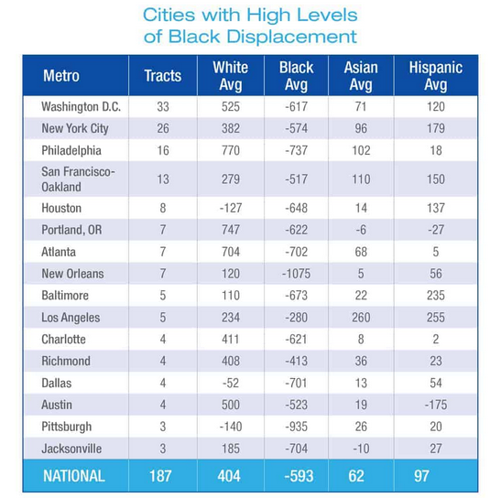
On the other hand, tracts with signs of Hispanic displacement were fewer than those that showed black displacement. However, the average number of displaced residents in every track was the same. The average residential decrease was 542 in the 45 tracts with indications of Hispanic displacement.
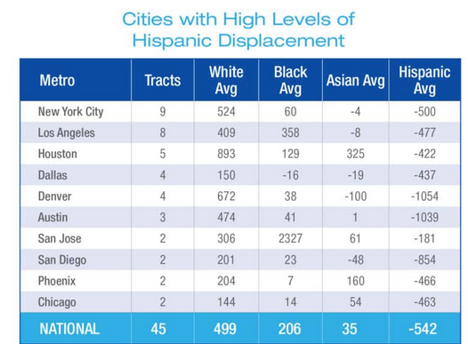
To assess regional differences in black and Hispanic displacement within the gentrifying tracts, the percentage of gentrifying tracts as well as tracts with signals of displacement. In the case of blacks, cities that showed the high levels of their displacement between 2000 and 2010 were clustered in the South.
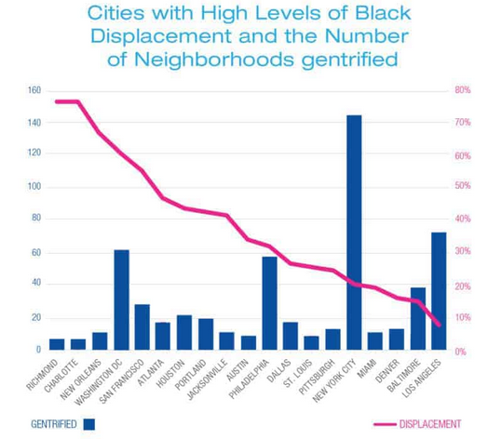
Also, from the census tracts examined, it was clear that Hispanic displacement took place in fewer cities as compared to black displacement. Nationally, only 45 census tracts were affected. New York City had the largest number of tracts impacted and Hispanics experienced nine tracts losses. Hispanic displacement was more pronounced in the west where Denver, Austin, Dallas and Houston indicate the highest percentages of displacement of the Hispanics as indicated in the graph below..
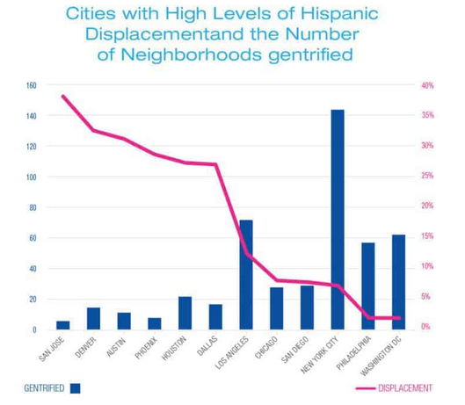
Conclusion
Many cities in the US have undergone gentrification. The study has indicated that the displacement of minorities is taking place in various cities and towns in the US. Further, it was visible that displacement of minority groups was significant in gentrifying tracts. Even though gentrification has some advantages, such as rising property value and reducing crime, its occurrence has specific adverse implications. Foremost, it fosters discrimination as the people of color, and the low-income individuals in the community are marginalized and displaced. The poor local inhabitants are usually displaced by the wealthiest individuals moving to the disenfranchised neighborhoods. It is essential to assess the proportion of minorities with signs of displacement to ensure racial and ethnic assimilation and foster integration.
References
Cocola-Gant, A. (2019). Gentrification and displacement: urban inequality in cities of late capitalism. In Handbook of Urban Geography. Edward Elgar Publishing.
Freeman, L. (2009). Neighbourhood diversity, metropolitan segregation and gentrification: What are the links in the US?. Urban Studies, 46(10), 2079-2101.
Freeman, L., & Braconi, F. (2004). Gentrification and displacement New York City in the 1990s. Journal of the American Planning Association, 70(1), 39-52.
Hamidi, E. (2020). Visualizing Narratives of Art as Gentrification in the" Artwashing" of Boyle Heights. Berkeley Undergraduate Journal, 34(1).
Hwang, J., & Ding, L. (2020). Unequal Displacement: Gentrification, Racial Stratification, and Residential Destinations in Philadelphia. American Journal of Sociology, 126(2), 354-406.
Preis, B., Janakiraman, A., Bob, A., & Steil, J. (2020). Mapping gentrification and displacement pressure: An exploration of four distinct methodologies. Urban Studies, 0042098020903011.
Smith, N. (2020). “Gentrification, the Frontier, and the Restructuring of Urban Space”: from Neil Smith and Peter Williams (eds) Gentrification of the City (1986). In The Urban Geography Reader (pp. 128-137). Routledge.
Tehrani, S. O., Wu, S. J., & Roberts, J. D. (2019). The Color of Health: Residential Segregation, Light Rail Transit Developments, and Gentrification in the United States. International Journal of Environmental Research and Public Health, 16(19), 3683.
Winsett, S. (2019). " It's Not Meant for Us": Exploring the Intersection of Gentrification, Public Education, and Black Identity in Washington, DC.

